**Loan Eligibility Prediction using Machine Learning Techniques**



**1. Introduction**

Various financial and banking institutions do a huge amount of business by extending loans to individuals and thus help in cash flow in the market and society. Before the loan is sanctioned the institutions predicts the probability that an individual would repay their loan in time or not. Machine learning models are effective in prediction of credit risk for customers who have applied for loans. In this post we will talk about how to use machine learning to predict the loan approval status of applicant. Various data processing techniques and exploratory data analysis have been covered in this article. The performance of models were compared based of different parameters.

**2. Problem Definition**

This dataset includes details of applicants who have applied for loan. The dataset includes details like credit history, loan amount, their income, dependents etc.

**Independent Variables:**

- Loan_ID

- Gender

- Married

- Dependents

- Education

- Self_Employed

- ApplicantIncome

- CoapplicantIncome

- Loan_Amount

- Loan_Amount_Term

- Credit History

- Property_Area

**Dependent Variable (Target Variable):**

- Loan_Status

We will build a model that can predict whether the loan of the applicant will be approved or not on the basis of the details provided in the dataset.

**3. Data Preprocessing and EDA**

The first step in building a model is to understand the dataset and prepare it for efficient prediction. In this step we use various cleaning techniques to produce a normally distributed dataset.

Importing necessary libraries

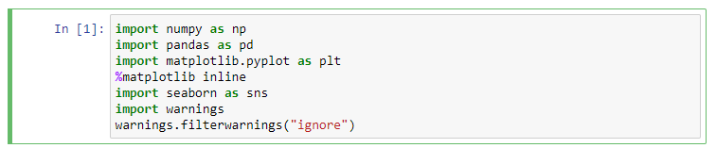

Loading the csv file and examination of dataset

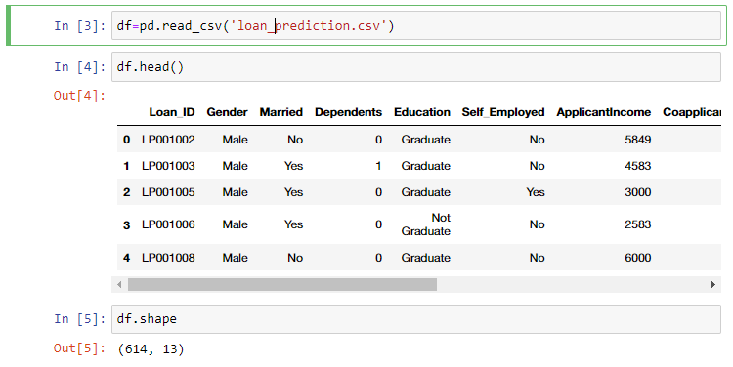

We see that there 614 entries and each of the entries has 12 features and 1 label. Let us look at the data description to have an initial look at the variation of data.

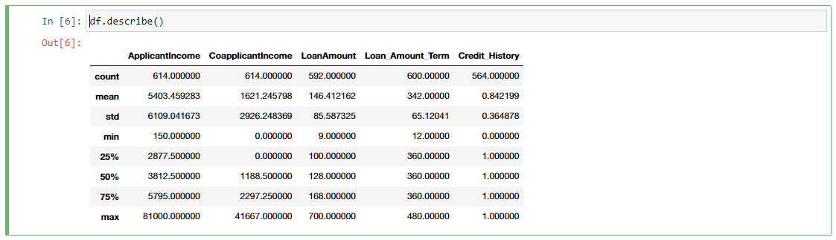

Only 5 columns pooped up using df.describe() method means that only 5 features have numerical values while the rest 7 features are categorical features. From the count of each feature we notice that there are some missing values in the dataset.

Lets find out how many missing values are there in the dataset.

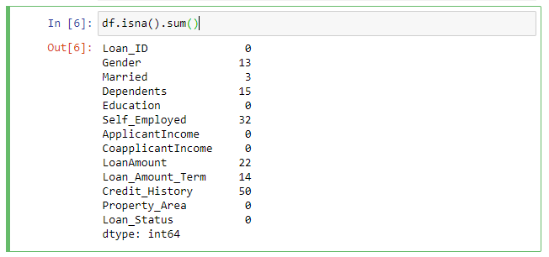

We will use some imputing technique at a later stage to impute the missing values in the dataset. We will first identify the categorical features and numerical features so that we can use proper encoder to encode those features.

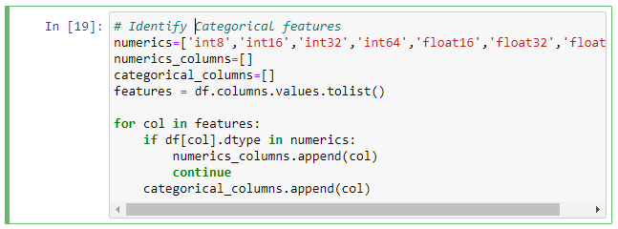

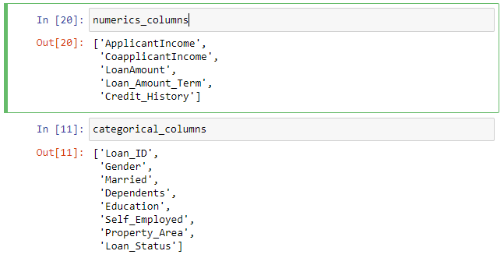

Bar plot can be very helpful in visualizing the categorical features.

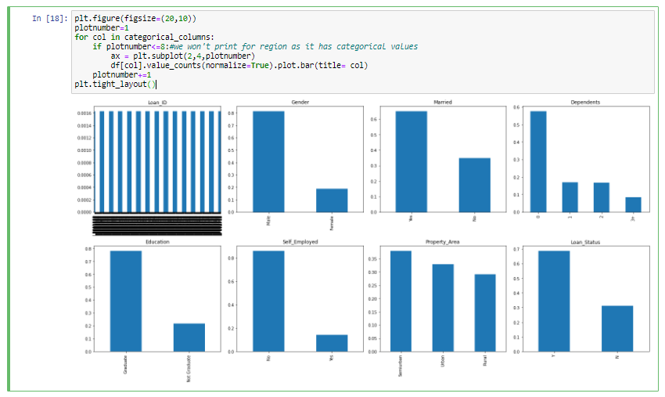

The following conclusion can be drawn from the box plot of categorical features:

* We can drop the feature 'Loan_ID' as it has nominal values.
* The feature ‘Dependents’has around 10% value 3+. We will have to address this as it is string and we may face problem at modelling stage.
* 81% of apllicants are male.
* 65% of applicants are married
* 58% of applicants don't have depedents, 17% have 1 depndenet nad 17 % have 2 dependents, while around 8% have more than 3 dependents

Now let us analyze if the loan approval is biased for a particular category of the applicants. The stacked bar chart of Gender vs Loan Status shows that there are no bias in loan approval.

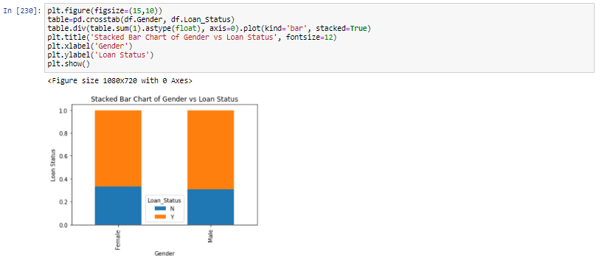

There is no bias in loan approval based on the marital status of the applicants.

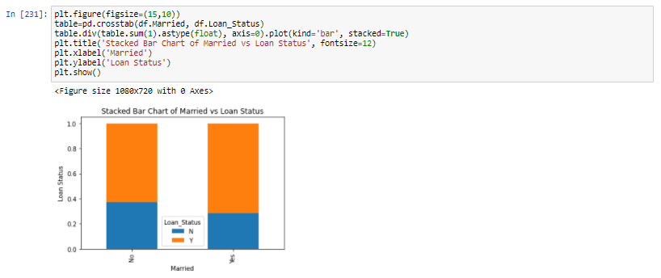

Stacked bar chart of other categorical features showed that the loan approval is not biased for number of dependents, level of education, whether the applicant is self-employed or not and the type of residence of applicants.

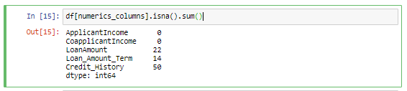

The numeric features have missing data set. So let us first impute values using iterative imputer. Iterative imputer is a good method for data imputation as this method predicts each missing feature as a function of other features which allows refined estimation of values backed with a logic.

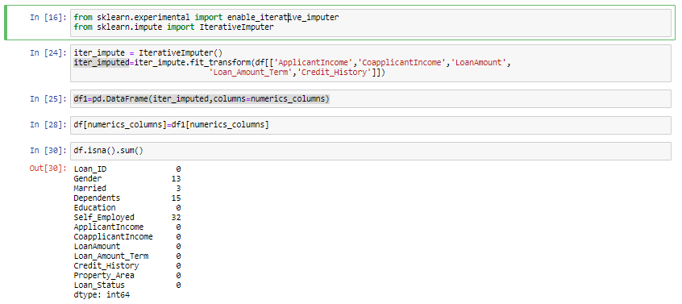

Now let us replace the missing categorical values with mode of that feature.

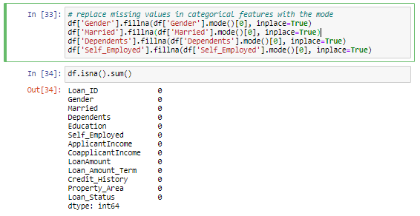

Now that we have imputed all the missing values we are done with the data cleaning. We need to do feature engineering for the feature ‘Dependents’. First we will replace all the values ‘3+’ in ‘Dependents’ feature and then we will encode all the categorical columns.

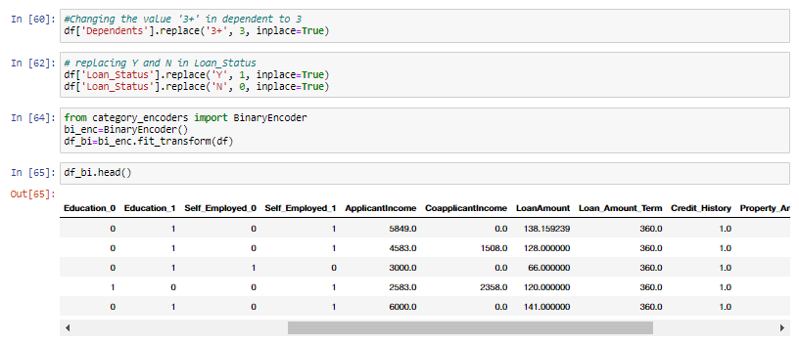

Let us look at the distribution of numeric features. The features must be normally distributed.

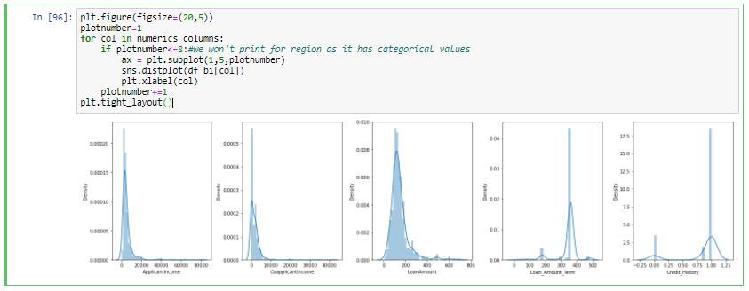

The distribution plot clearly shows that there are skewness in the features. We will use the Box plot method to remove the outliers in the dataset. Removal of outliers creates a normal distribution in some of the variables and makes transformations for other variables more effective. Outliers increase the variability in the data and removal of outliers may make the data significant.

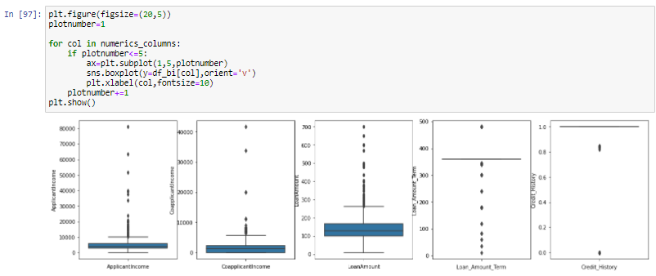

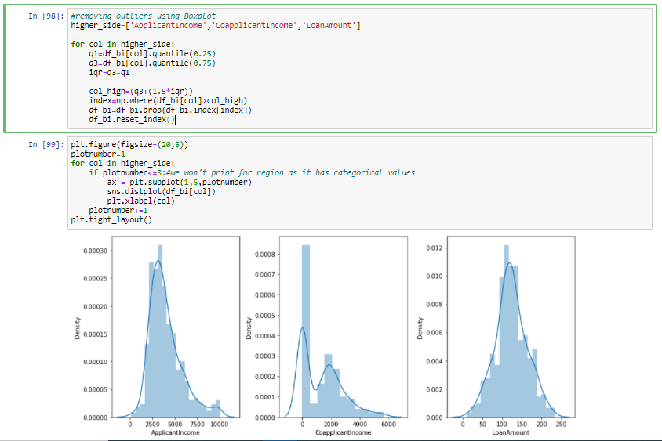

After outlier removal we have achieved normal distribution of the data. Let us find out correlation matrix and plot heatmap to understand the relation between feature vs feature. This is going to help in feature selection and we will the feature which are highly correlated.

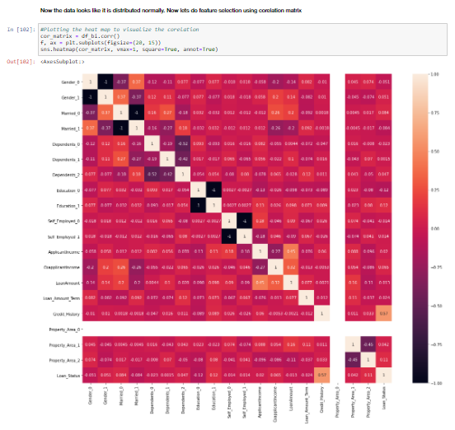

The heat map shows that the correlation between the features is not that significant. Hence, we will keep all the features for model prediction. The next step is to determine if there is multidimensional collinearity. We will split the features and label and use variance inflation factor to reduce dimensionality

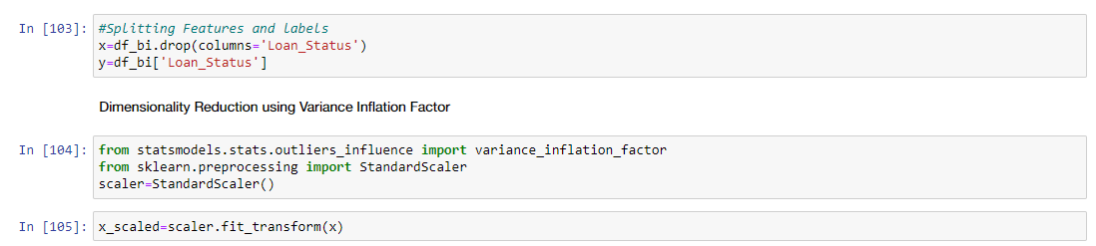

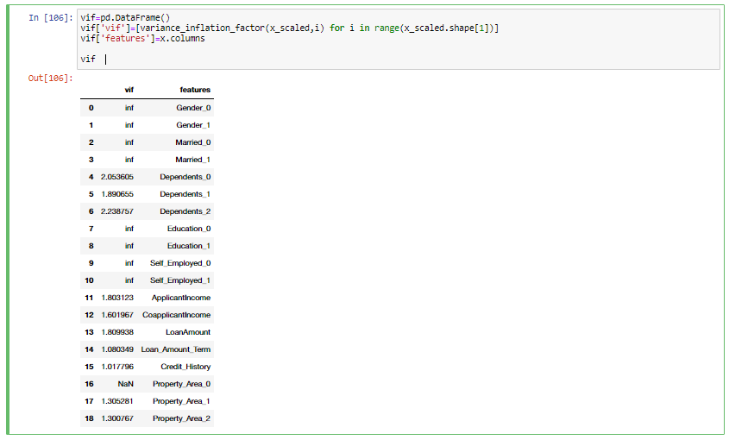

The vif for all the features is less than 5. Hence, the dataset doesn’t have multidimensional collinearity. Let us check if the labels are balanced or not as balanced dataset are preferred to efficiently predict and verify model performance.

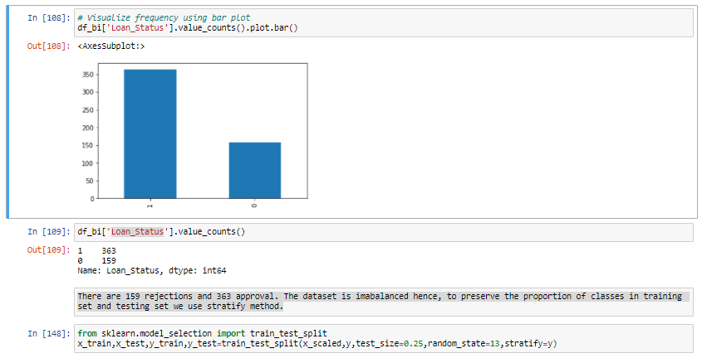

There are 159 rejections and 363 approval. The dataset is imbalanced hence, to preserve the proportion of classes in training set and testing set we use stratify method.

**EDA Concluding Remarks**

* The dataset has 614 entries each entry has 12 features and 1 label
* The null values in the dataset are imputed with mode for categorical features and iterative imputer for numerical features
* The feature Loan_ID is dropped as it has nominal values.
* Feature Engineering was done for ‘Dependents’.
* 81% of applicants are male.
* 65% of applicants are married
* 58% of applicants don't have dependents, 17% have 1 dependent and 17 % have 2 dependents, while around 8% have more than 3 dependents
* Loan approval is not biased for gender, marital status, number of dependents, level of education, whether the applicant is self-employed or not and the type of residence of applicants.
* The categorical features were encoded using Binary Encoder
* The outliers in the dataset were handled using Boxplot
* Feature Selection was carried out using Heat Map
* Multidimensional collinearity was checked using Variance Inflation Factor
* The label was imbalanced and the proportion of classes was maintained using stratify during train test split

**4. Building Machine Learning Models**

The following models were tested to predict the approval of loan:

1. Logistic Regression
2. KNN Classifier
3. Decision Tree Classifier
4. Random Forest Classifier
5. XG Boost Classifier

The hyper parameters for the models were tuned using Grid Search CV technique wherever applicable. The following table summarizes the performance of model:

|  |  |  |  |  |  |  |  |
| --- | --- | --- | --- | --- | --- | --- | --- |
| **S. No.** | **Model Name** | **Accuracy** | **Precision** | **F1 Score** | **Accuracy after tuning** | **Precision after tuning** | **F1 Score after tuning** |
| 1. | Logistic Regression | 0.82 | 0.81 | 0.76 | - | - | - |
| 2. | KNN | 0.76 | 0.72 | 0.68 | 0.76 | 0.72 | 0.68 |
| 3. | Decision Tree | 0.74 | 0.71 | 0.71 | 0.83 | 0.85 | 0.77 |
| 4. | Random Forest | - | - | - | 0.79 | 0.79 | 0.72 |
| 5. | XG Boost | - | - | - | 0.83 | 0.85 | 0.77 |

The models were also compared from ROC Curve and AUC. The model which has the highest AUC curve is the best considered as the best fit.

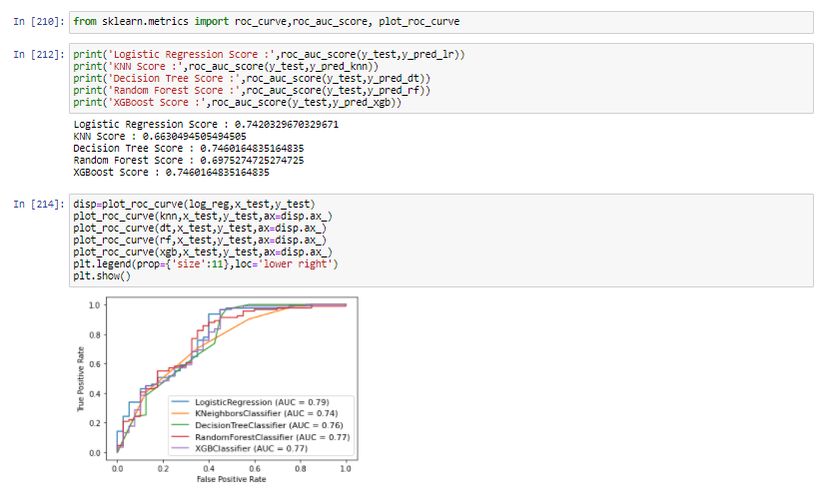

The AUC is highest for the Logistic Regression. However, the accuracy and precision is highest for Decision Tree Classifier. When it comes to classification model it is standard practice to use precision and recall. Higher precision means that the model is accurately predicting the positive instances into positive class. We select Decision Tree as our final model for prediction of loan approval. The hyper tuned parameters for the Decision Tree Classifier are:

{'criterion': 'gini', 'max_depth': 5, 'min_samples_leaf': 20, 'min_samples_split': 3}

The classification report for the finalized model is shown below:

precision recall f1-score support

0 0.88 0.53 0.66 40

1 0.82 0.97 0.89 91

accuracy 0.83 131

macro avg 0.85 0.75 0.77 131

weighted avg 0.84 0.83 0.82 131

**5. Concluding Remarks**

We cleaned the data, performed EDA and successfully trained a model and tuned the hyper parameters to predict the response of a loan application based on the features and dataset available with us. The Decision Tree Classifier proved to be the best model in prediction due to its high precision and accuracy. I hope this has proven to be an informative topic.

You may refer to my repository for detailed code

<https://github.com/dewangan-ashishk/Evaluation-Project/blob/d3eb320df22fe136ccf21c7131904cc3feeefc60/Loan%20Prediction%20Final.ipynb>